Item | Needed ✔ | Present ✔  NXT Reset Form | Item | Needed ✔ | Present ✔ | Item | Needed ✔ | Present ✔
1 X 16 w/ Holes (Grey) | 4 |  | 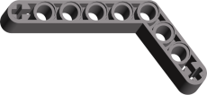  Beam 4 x 6 Liftarm Bent 53.5 (Dark Grey) | 4 |  |   Beam 7 (Dark Grey) | 4
  1 X 8 w/ Holes (Grey) | 4 |  | 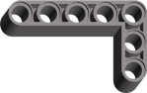  Beam 3 x 5 Bent 90 (Dark Grey) | 8 |  |   Beam 5 (Dark Grey) | 4
  1 X 6 w/ Holes (Grey) | 4 |  |   Beam 2 x 4 Liftarm Bent 90 (Dark Grey) | 4 |  |   Beam 3 (Dark Grey) | 10
  1 X 4 w/ Holes (Grey) | 4 |  | Beam 15 (Dark Grey) | 4 |  |   Plate 2 x 8 with Holes (Grey) | 2
  1X 2 w/ Hole (Grey) | 4 |  | Beam 13 (Dark Grey) | 2 |  |   Plate 2 x 6 with Holes (Grey) | 2
  1 X 2 w/ Axlehole (Grey) | 2 |  |   Beam 11 (Dark Grey) | 2 |  |   Plate 2 x 4 with Holes (Grey) | 2
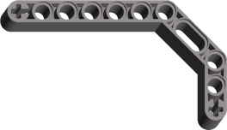  Beam 3 x 3.8 x 7 Liftarm Bent 45 Double (Dark Grey) | 4 |  |   Beam 9 (Dark Grey) | 6 |  |   Plate 1 x 4 (Grey) | 4
  Plate 1 x 2 (Grey) | 4 |  | Axle Pin with Friction (Blue) | 10 |  |   Gear 24 Tooth (Grey) | 4
  2 X 2 (Grey) | 4 |  | Axle Pin (Tan) | 8 |  |   Gear 24 Tooth Crown Type 3 (Grey) | 2
  1 X 2 (Grey) | 8 |  | Pin Long with Stop Bush (Black) | 8 |  |   Gear 20 Tooth Double Bevel (Grey) | 2
  Tile 1 x 2 with Groove (Dark Grey) | 2 |  | Pin with Friction and Slots (Black) | 60 |  |   Gear 16 Tooth (Grey) | 4
Technic Bush (Grey) | 10 |  | 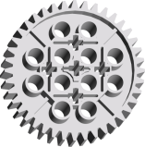  Gear 40 Tooth (Grey) | 2 |  |   Gear 12 Tooth Double Bevel (Black) | 4
Technic Bush 1/2 Smooth (Yellow) | 10 |  |   Gear 36 Tooth Double Bevel (Black) | 2 |  |   Gear 8 Tooth (Grey) | 4
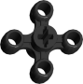  Knob Wheel (Black) | 4 |  |   Angle Connector #1 (Black) | 2 |  | 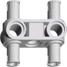  Pin Connector Perpendicular 1 x 3 w/ 4 Pins (Grey) | 2
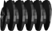  Worm Screw (Black) | 2 |  |   Axle Joiner Perpendicular Double (Dark Grey) | 2 |  |   Beam 3 x 0.5 Liftarm w/ Boss and Pin (Grey) | 2
  Axle Joiner Perpendicular (Grey) | 20 |  | 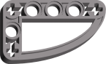  Beam 3 x5 x 0.5 Liftarm Bent 90 Quarter Ellipse (Grey) | 4 |  | Axle 12 (Black) | 2
  Axle Joiner Perpendicular with 2 Holes (Dark Grey) | 4 |  | 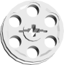  Wedge Belt Wheel (Grey | 4 |  | Axle 10 (Black) | 2
  Axle Joiner Perpendicular 3L (Black | 8 |  |   Wedge Belt Wheel Tyre (Black) | 4 |  | Axle 8 (Black) | 2
Axle Joiner Offset (Black) | 4 |  | 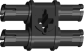  Pin 3L Double (Black) | 2 |  | Axle 6 (Black) | 4
Axle 4 (Black) | 6 |  | 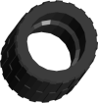  Tyre 24 x 14 with Shallow Staggered Treads (Black) | 2 |  |   Minifig Head | 1
Axle 5 (Grey) | 8 |  |   Wheel 30.4 x 14 with Holes on Both Sides (Grey) | 2 |  |   Minifig Torso | 1
Axle 3 (Grey) | 14 |  | 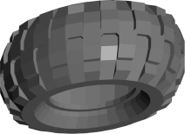  Tyre 56 x 26 (Black) | 4 |  |   Minifig Hips and Leg | 1
Axle 5.5 w/ Stop (Dark Grey) | 2 |  | 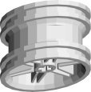  Wheel 43.2 x 22 w/out Pinholes (Grey) | 4 |  | 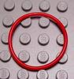  Rubber Belt Medium (Red or Blue) | 2
Axle 2 (Red) | 8 |  |   Minifig Cap (Red) or hair | 1 of either |  | 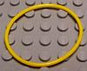  Rubber Belt Extra Large (Yellow or Blue) | 2
  Electric Light & Sound Brick 1 x 2 with Single Side Light (White) | 3 |  |   1 X 2 (Translucent Red) | 1 |  | Pin Long with Friction and Slot (Black) | 36
1 X 2 (Translucent Green) | 1 |  | 1 X 2 (Translucent Yellow) | 1

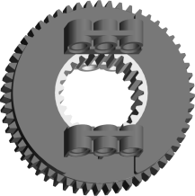  Turntable with Hole Base (Grey) | 1 |  |   Ball diameter 5.2cm (1 Red, 1 Blue) | 2
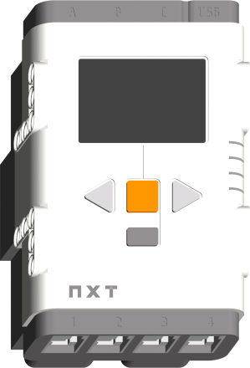  “Brick” | 1  Fully  Charged |  | 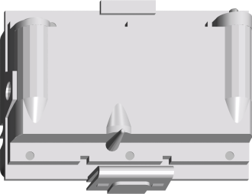  7.4V Battery Rechargeable NXT Container | 1
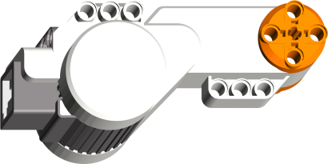  Motor | 3 |  | 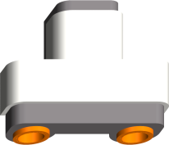  Ultrasonic Sensor | 1
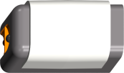  Light Sensor | 1 |  | 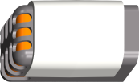  Sound Sensor | 1
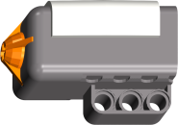  Touch Sensor | 2 |  | 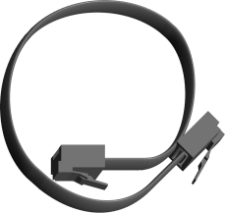  8-inch Cable | 1
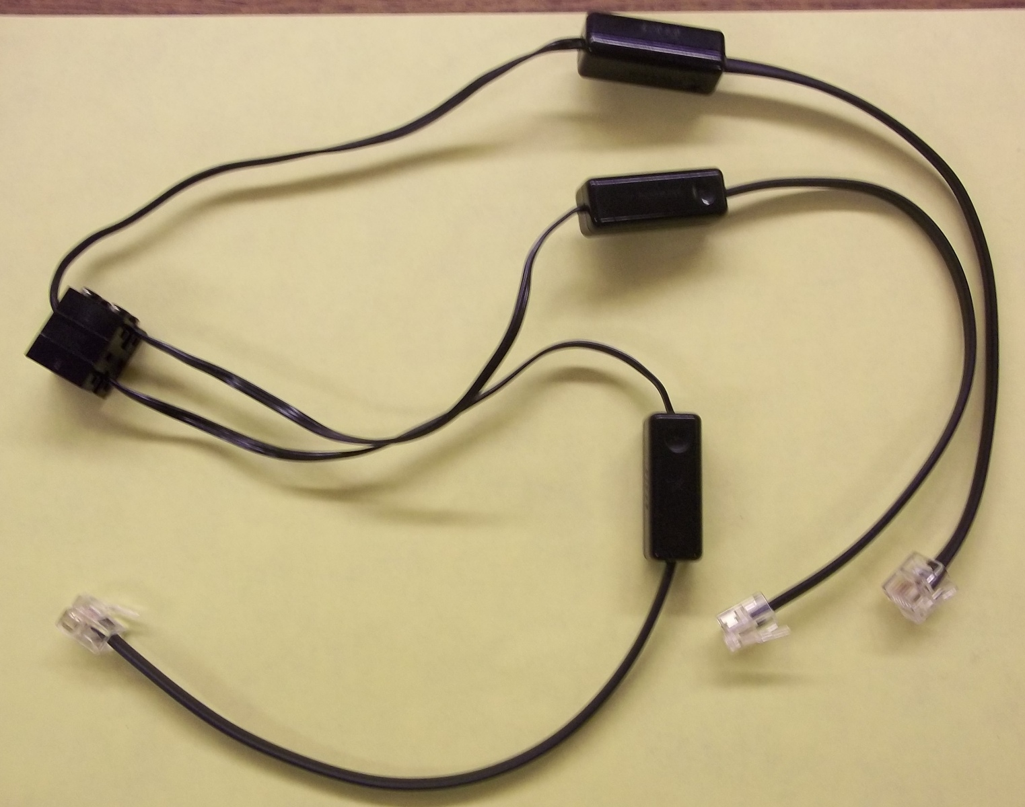  Conversion Cable | 3 |  | 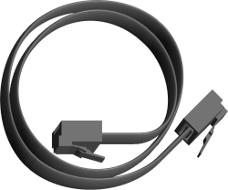  14-inch Cable | 4
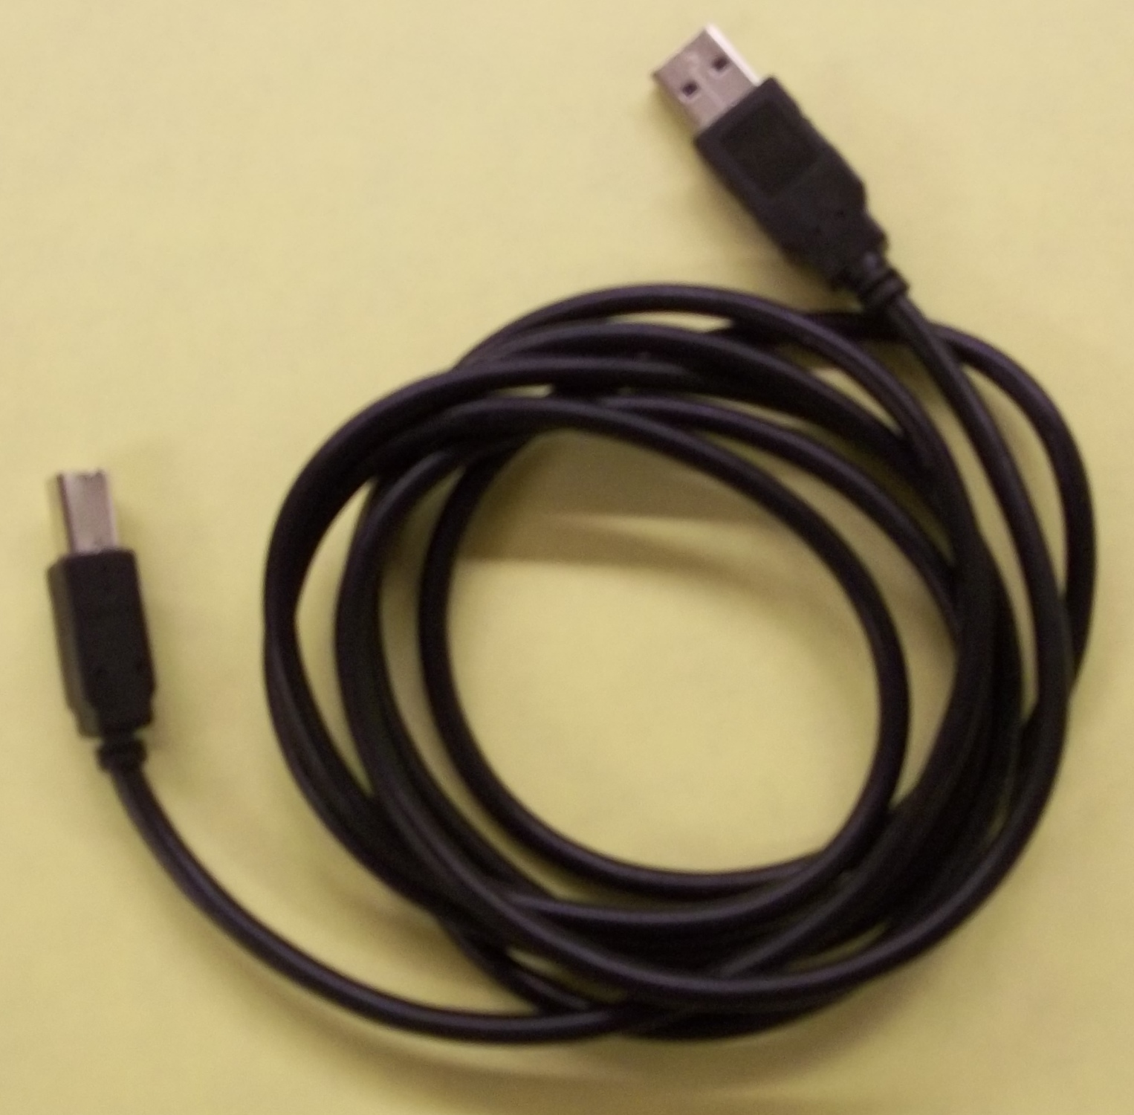  USB Cable | 1 |  | 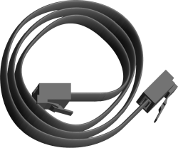  20-inch Cable | 2
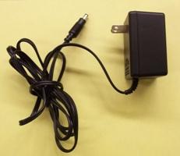  Power Cable | 1 |  | 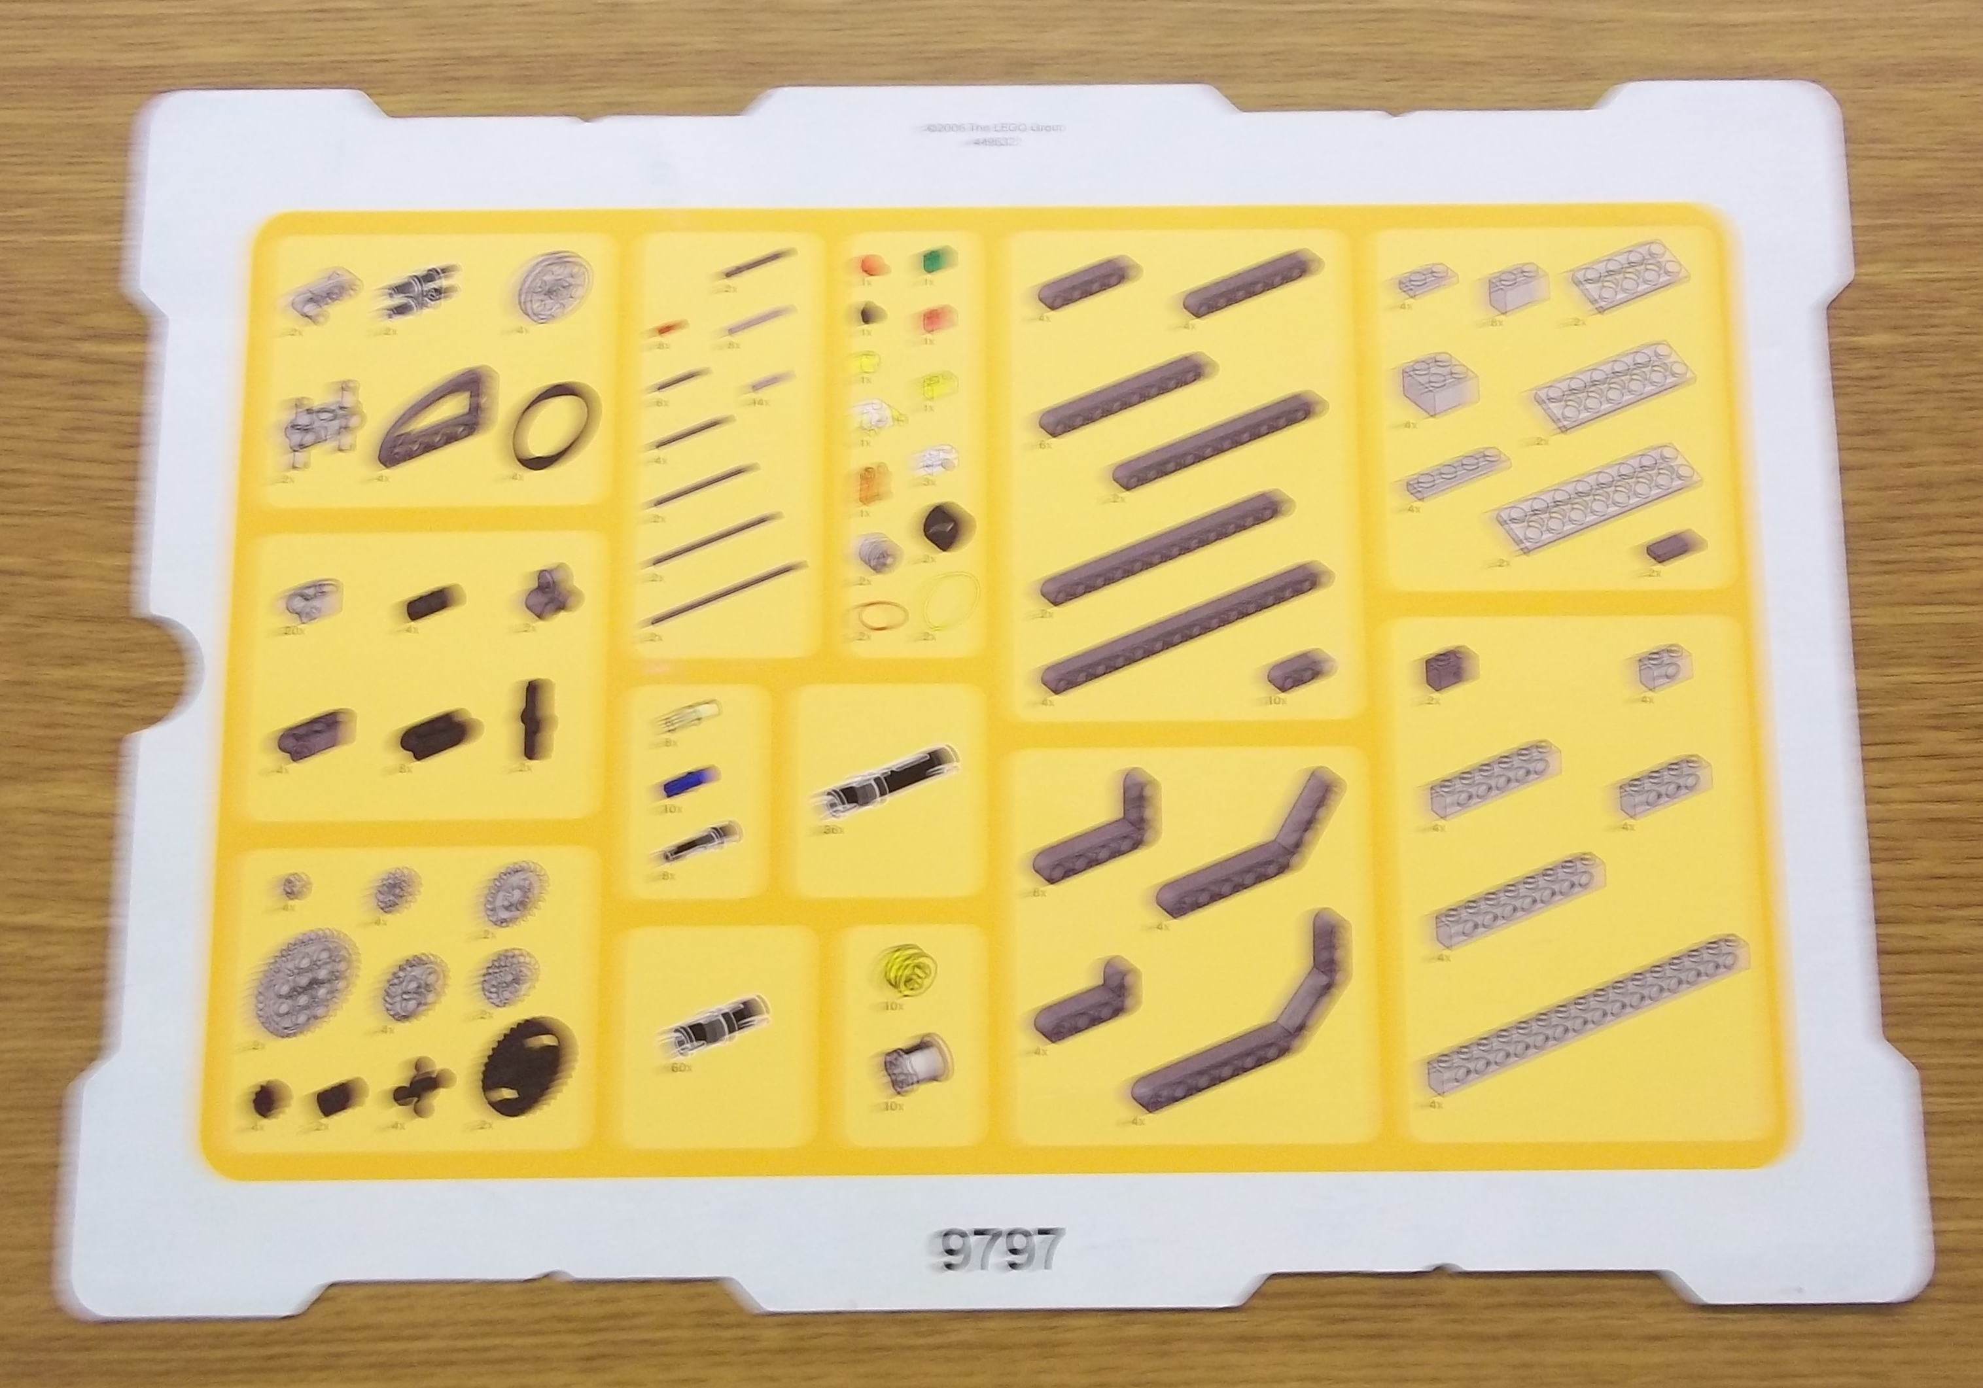  Parts Sheet #1 | 1
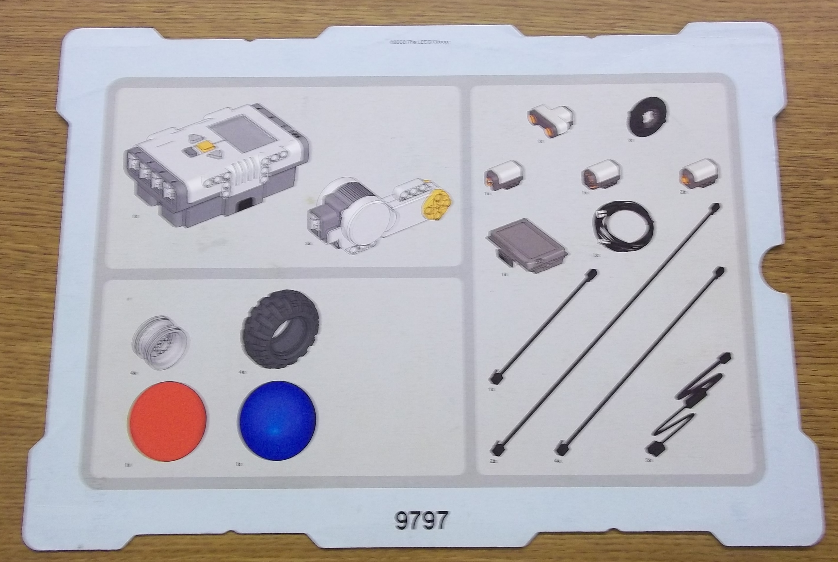  Parts Sheet #2 | 1
Name:

____________________________

Organization:

____________________________

Date:
____________________________

Kit Number:
____________________________

Brick Charged? Y / N

Notes/Comments/Missing Pieces:

